## **NATIONAL UNIVERSITY OF MODERN LANGUAGES, ISLAMABAD**

## NUML logo, Vector Logo of NUML brand free download (eps, ai, png, cdr ...

**Web Engineering - Lab**

**Lab Exam**

**Submitted By**

**Umer Hassan Khan**

**SP21020**

**Submitted To**

**Ma’am Nabeela Bibi**

# **Date: 18/12/2023**

<!DOCTYPE html>

<html lang="en">

<head>

    <meta charset="UTF-8">

    <meta name="viewport" content="width=device-width, initial-scale=1.0">

    <title>Library Management System</title>

    <style>

        body {

            font-family: Arial, sans-serif;

            margin: 20px;

            background-color: #f5f5f5;

        }

        h2 {

            color: #333;

        }

        form {

            margin-top: 20px;

            background-color: #fff;

            padding: 20px;

            border-radius: 8px;

            box-shadow: 0 0 5px rgba(0, 0, 0, 0.1);

        }

        label {

            display: block;

            margin-bottom: 8px;

            color: #333;

        }

        input, button {

            width: 100%;

            padding: 8px;

            margin-bottom: 15px;

            border: 1px solid #ccc;

            border-radius: 4px;

            box-sizing: border-box;

        }

        button {

            background-color: #000000;

            color: white;

            cursor: pointer;

        }

        button:hover {

            background-color: #45a049;

        }

    </style>

</head>

<body>

<?php

// Database connection

$host = "localhost";

$username = "root";

$password = "";

$database = "library";

$conn = new mysqli($host, $username, $password, $database);

if ($conn->connect_error) {

    die("Connection failed: " . $conn->connect_error);

}

// Create Operation - Add new book

if ($_SERVER["REQUEST_METHOD"] == "POST") {

    $title = $_POST["title"];

    $author = $_POST["author"];

    $publication_year = $_POST["publication_year"];

    $quantity_available = $_POST["quantity_available"];

    // Check if the book already exists

    $check_sql = "SELECT * FROM books WHERE title = '$title' AND author = '$author'";

    $check_result = $conn->query($check_sql);

    if ($check_result->num_rows > 0) {

        echo "<p>Book already exists in the database.</p>";

    }

    else {

        // Book does not exist, insert it

        $insert_sql = "INSERT INTO books (title, author, publication_year, quantity_available)

                       VALUES ('$title', '$author', '$publication_year', '$quantity_available')";

        if ($conn->query($insert_sql) === TRUE) {

            echo "<p>New book added successfully!</p>";

        } else {

            echo "Error: " . $insert_sql . "<br>" . $conn->error;

        }

    }

}

// Read Operation - Display books as text

echo "<h2>Book List</h2>";

// Search functionality

if (isset($_GET['search'])) {

    $search = $_GET['search'];

    $search_sql = "SELECT * FROM books WHERE title LIKE '%$search%' OR author LIKE '%$search%'";

    $result = $conn->query($search_sql);

} else {

    $result = $conn->query("SELECT DISTINCT * FROM books");

}

if ($result->num_rows > 0) {

    while ($row = $result->fetch_assoc()) {

        echo "<p><strong>Title:</strong> {$row['title']}<br>

              <strong>Author:</strong> {$row['author']}<br>

              <strong>Publication Year:</strong> {$row['publication_year']}<br>

              <strong>Quantity Available:</strong> {$row['quantity_available']}</p>";

    }

} else {

    echo "<p>No books found.</p>";

}

$conn->close();

?>

<!-- HTML Form for Create Operation -->

<form method="post" action="">

    <h2>Add New Book</h2>

    <label for="title">Title:</label>

    <input type="text" name="title" required>

    <label for="author">Author:</label>

    <input type="text" name="author" required>

    <label for="publication_year">Publication Year:</label>

    <input type="number" name="publication_year">

    <label for="quantity_available">Quantity Available:</label>

    <input type="number" name="quantity_available" required>

    <button type="submit">Add Book</button>

</form>

<!-- HTML Form for Search Operation -->

<form method="get" action="">

    <h2>Search Books</h2>

    <label for="search">Search by Title or Author:</label>

    <input type="text" name="search">

    <button type="submit">Search</button>

</form>

</body>

</html>

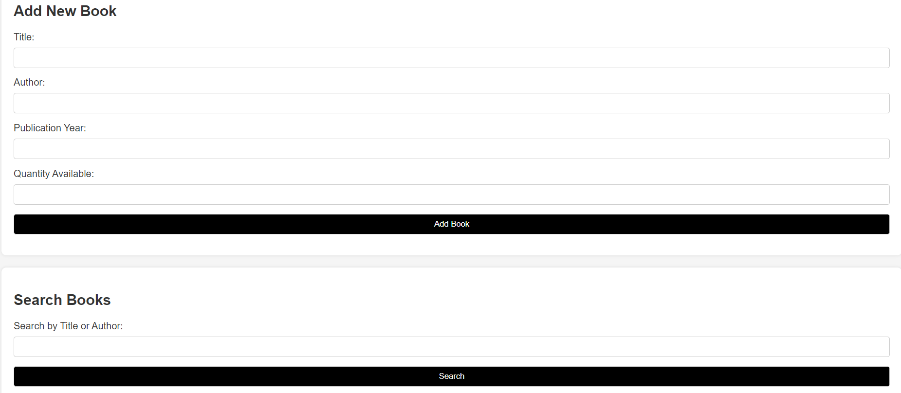

**Databaase Table**

